Considering that the amount of information offered by an atlas is one the most important characteristics of a digital atlas, we found that the most useful digital atlas from the list was the one offered by the Natural Earth Data Site: . http://www.naturalearthdata.com/
We found it very interesting that the data offered by this website is categorized regarding the level of detail, basically the scale at which the data is offered. Thus, when needed, the users can select the level of precision they need for their queries and work with a single data set for one characteristic, instead of looking in different places for the information they need. There are also three data themes: cultural vector data themes, physical vector data themes and raster data themes so that it is easier to browse through the entire collection.
The website uses the geographic coordinate system together with the WGS84 datum so that all information have the same reference and are linked. Another important aspect was the possibility of previewing the data and its metadata before the download.
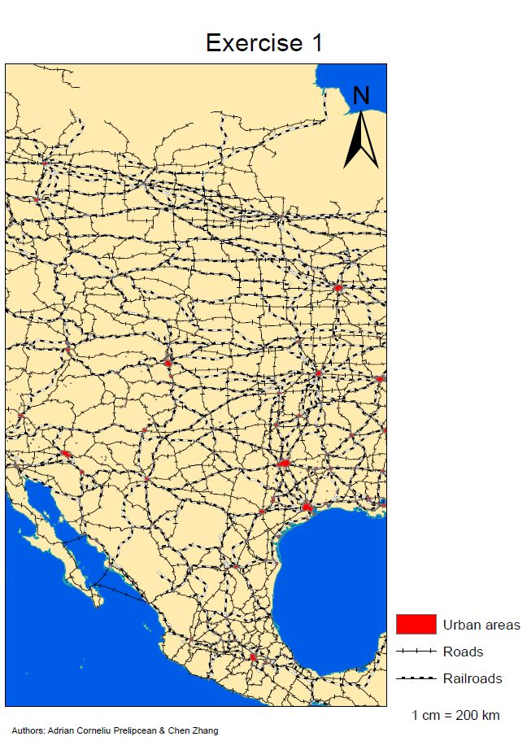
Using the data downloaded from http://www.naturalearthdata.com/, we designed a map that focuses on presenting different transportation means and the urban areas. For this, we downloaded the following shapefiles from the Natural Earth Data Website, focusing on large scale data: 10m_coastline.shp, 10m_ocean.shp, 10m_railroads.shp, 10m_roads.shp, 10m_urban_areas.shp.
After downloading these files, we added them to ArcGIS where we handled them to obtain the end product. The order of layers was decided in the following way: the ocean and the land were the bottom most layer so that they may, followed by railroads, roads and as the first layer, the urban areas. After doing this, we agreed upon using the symbols that are found in the legend for the urban areas, roads and railroads.
Analyzing the map, we see that the transportation network is more dense near the urban areas.

Figure 1: Creating a map using data from a useful website (http://www.naturalearthdata.com/)

We chose the Natural Earth Data Site because of the large amount of downloadable information available. As it can be seen, having access to a large amount of data can lead to different thematic maps.

The website that we found least useful was the National Geographic Map Machine found at http://maps.nationalgeographic.com/map-machine. The main disadvantage is its one sided data availability, the one data they offer is location information and labels. The user has no access whatsoever to different data types, there are no downloading options.

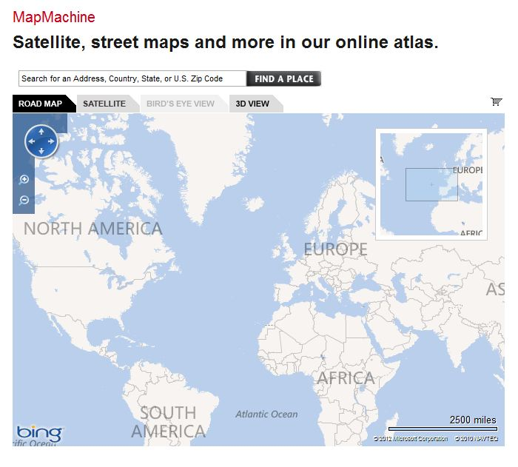
Figure 2: Creating a map using data from a not so useful website
(http://maps.nationalgeographic.com/map-machine)

